Software Solution Testing Document

Ivy Tech Community College

Blue team – SDEV 265 – Fall 2025

October 15th 2025

# Main Launcher (tkinter GUI)

### Objectives:

* **Display App Title** prominently at the top of the launcher.
* **Showcase each game** with custom cover-art buttons for visual appeal and intuitive selection.
* Include **“Coming Soon” placeholders** for future games and as a fallback for time constraints.
* Add an **About button** to highlight the app’s purpose and development team.
* Ensure each game **launches in a separate window**, while the main launcher **hides during gameplay**.
* When a game is closed, the **launcher reappears seamlessly**, resuming its original position.

### Testing:

**Initial start up:**

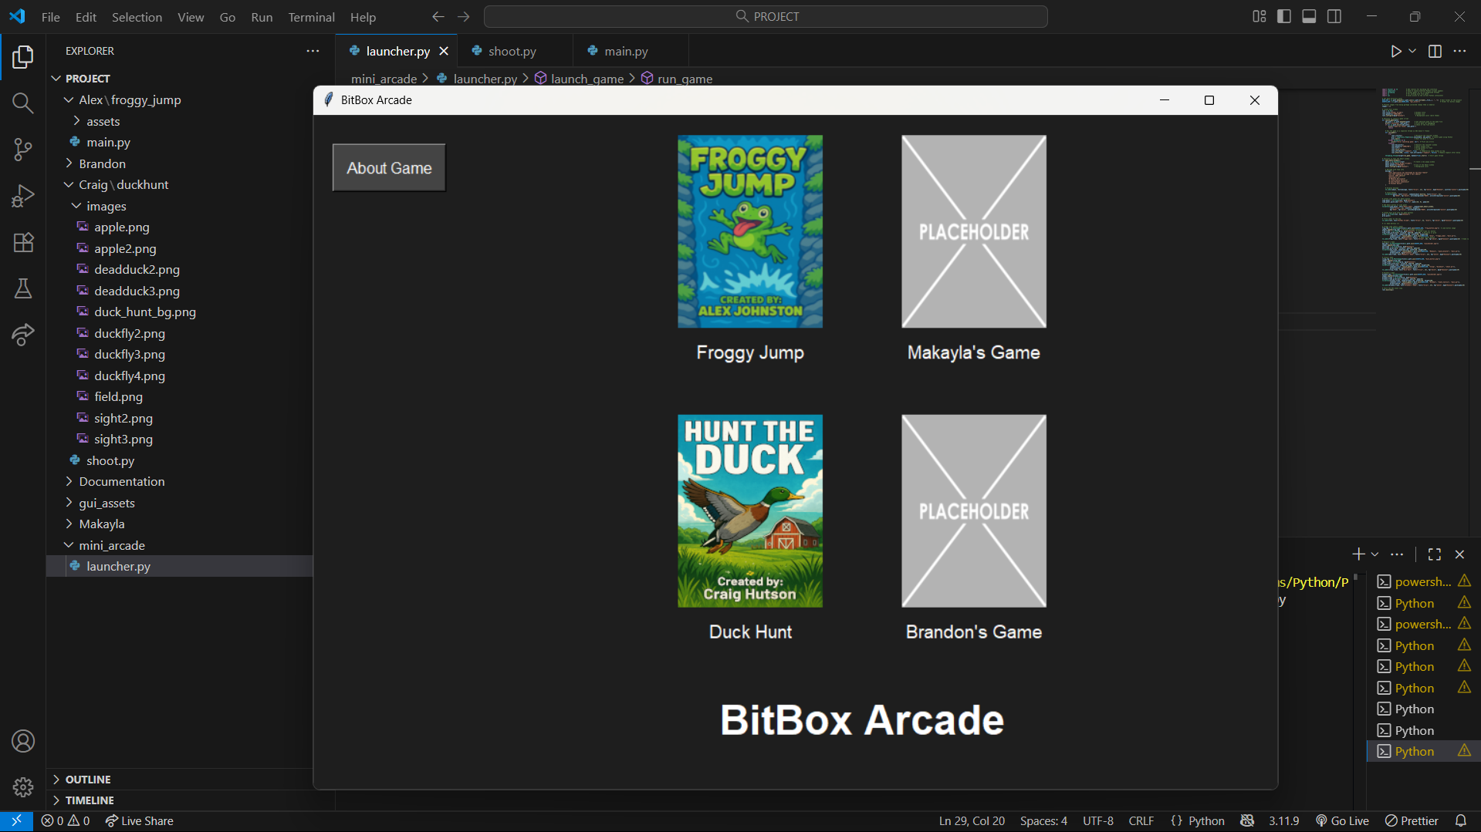

**Clicking about game:**

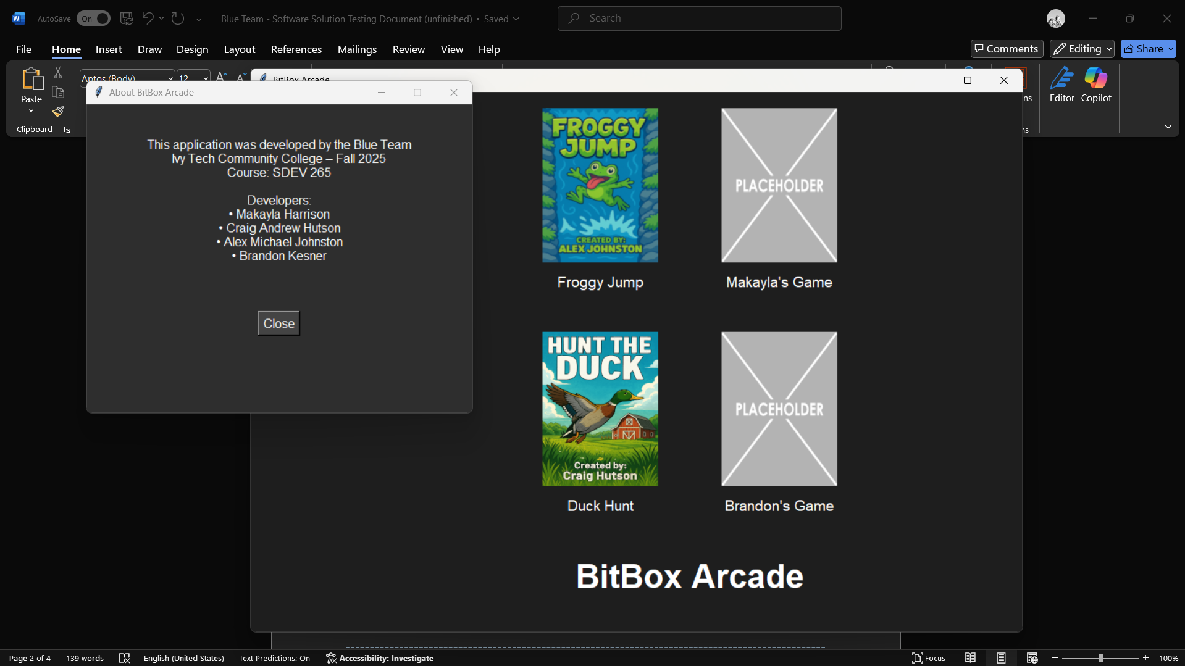

**Clicking Froggy Jump:**

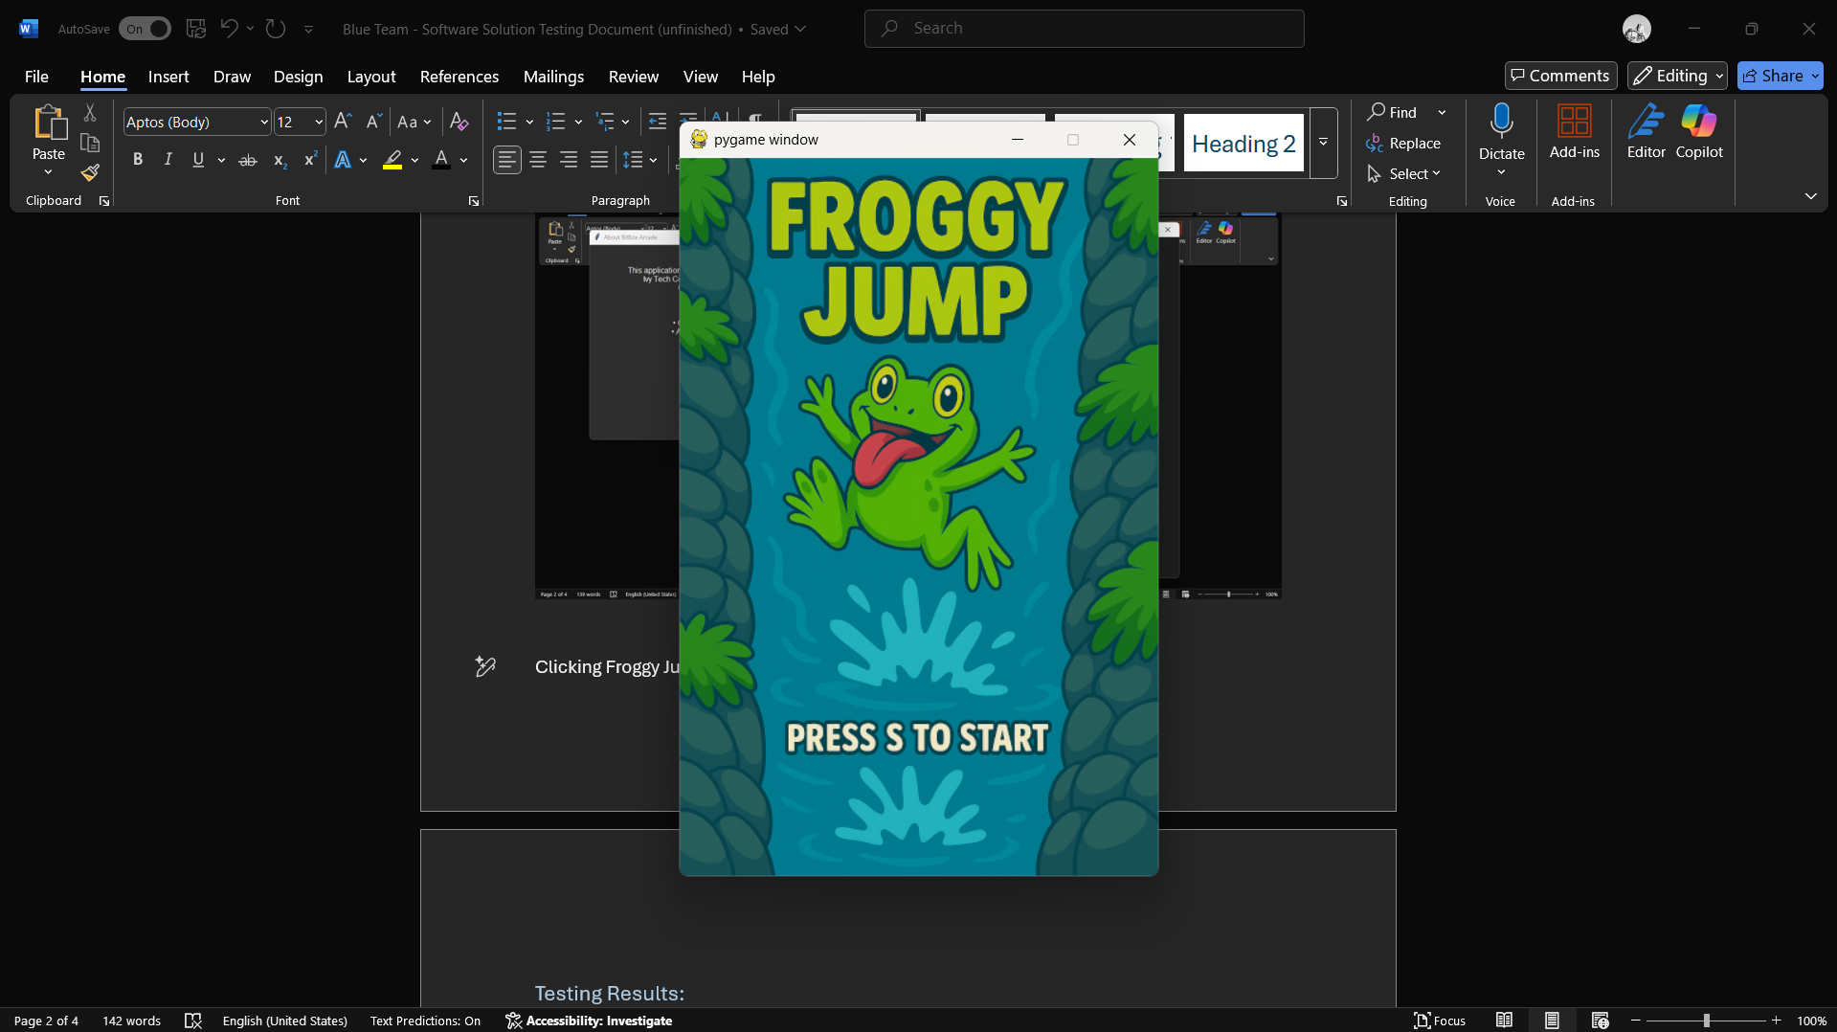

**Closing froggy jump:**

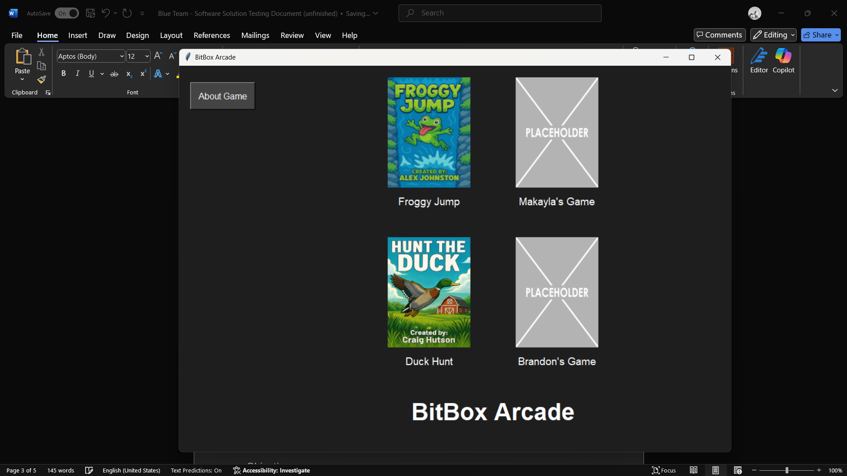

**Opening Hunt The duck:**

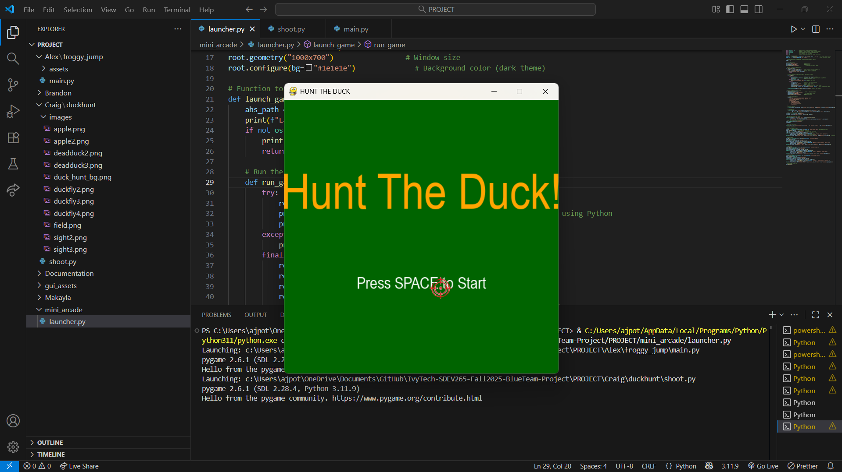

**Closing Hunt The Duck:**

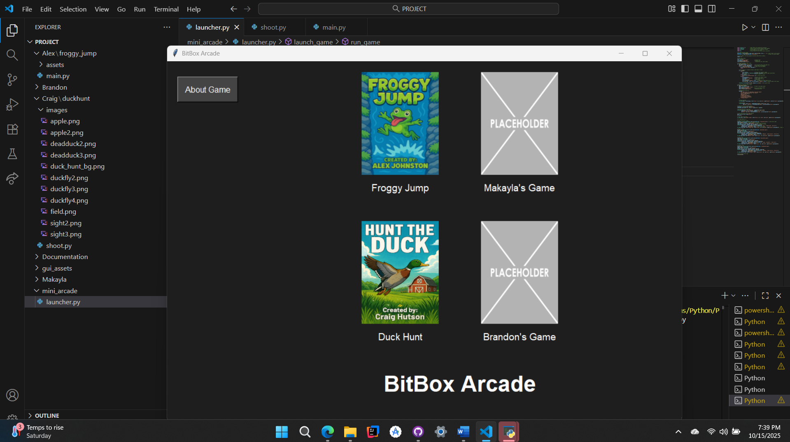

**Opening David and Goliath:**

**Closing David and Goliath:**

**Opening Tower Defense:**

**Closing Tower Defense:**

### Testing Results:

**1. App Title Display**

* **Implementation:** The launcher displays the application title prominently at the top using a styled Label widget.
* **Testing:** Verified on launch across multiple screen sizes. Title renders consistently and remains fixed.
* **Result:** Success. Title is clear, centered, and visually distinct.

**2. Custom Cover-Art Buttons for Each Game**

* **Implementation:** Each game is represented by a unique button featuring its cover art, using PhotoImage and Button widgets.
* **Testing:** Clicked each button to confirm image loads correctly and triggers the associated game.
* **Result:** Success. All cover-art buttons are responsive and visually accurate.

**3. “Coming Soon” Placeholder Buttons**

* **Implementation:** Placeholder buttons labeled “Coming Soon” are styled to match the launcher theme and disabled to prevent interaction.
* **Testing:** Verified visual consistency and confirmed they do not trigger any action when clicked.
* **Result:** Success. Placeholders are functional and serve as clear visual cues for future content.

**4. About Button**

* **Implementation:** Added an “About” button that opens a pop-up window with app purpose and developer info.
* **Testing:** Clicked to open and close the pop-up. Confirmed content loads correctly and window closes cleanly.
* **Result:** Success. About section is informative and stable across launches.

**5. Game Launch in Separate Window + Launcher Hide**

* **Implementation:** Each game launches in its own Toplevel() window. The main launcher uses .withdraw() to hide during gameplay.
* **Testing:** Launched each game individually:
  + **Duck Hunt:** Launcher hides, game opens fullscreen, no residual launcher window.
  + **Froggy Jump**: Launcher hides, game opens fullscreen, no residual launcher window.
  + **David and Goliath:** Launcher hides, game opens fullscreen, no residual launcher window.
  + **Tower Defense:** Launcher hides, game opens fullscreen, no residual launcher window.
* **Result:** Success. Launcher hides cleanly for all games.

**6. Launcher Reappears After Game Exit**

* **Implementation:** On game window close, the launcher uses .deiconify() to return to its original position.
* **Testing:** Closed each game manually and via in-game exit buttons:
  + Launcher reappears in correct position and state.
  + No duplicate windows or focus issues.
* **Result:** Success. Launcher resumes seamlessly after each game session.

### --------------------------------------------------------------------------------------------------

# Froggy Jump

### Objectives:

* Create/implement Background
* Create/implement a random appearing platform(s) for the player to scale
* Create/implement a player character
* Create/Implement player character animations that change based on physics
* Create/implement a lower border to end the game
* Create/implement an enemy sprite with collision physics directed to the player sprite.
* Create/implement player physics
* Create/implement random generation of platforms
* Create/implement random generation of enemy sprites
  + Specifically on platforms only
  + For fun, spiders have 2 sprites, one is inverted, every 2 to 5 seconds they switch photos, making the spider appear more alive and not so static.
* Create/ implement sounds upon :
  + Collision with enemy
  + Jump
  + Die
* Create/implement background music
* Create implement a start screen
* Create implement player controls
* Create implement death scenes
  + For fun, 13 different death scenes was implemented that is to display randomly thru an array, so more can easily be added later.
  + This gives a creative way of replayability.
* Create/implement a scoring system

### Testing:

**Initial launch:**

(Background music is instantly heard.)

# **Pressing the S Key:**

**Current Behavior:**

* Pressing the **S key** from the start menu immediately launches the game without any intermediary screens.
* There is **no loading screen** or **control/instruction overlay**, which may cause momentary confusion for first-time players unfamiliar with the controls.
* **Background music** begins automatically and plays continuously, even before gameplay starts.

**User Experience Note:**

* While the instant launch is snappy, the lack of a brief transition or control guide could be disorienting. A simple pre-launch screen showing key bindings and gameplay tips would improve onboarding and polish.

**Minimized Runtime Stability**

**Technical Highlight:**

* When the game is **minimized**, it enters a passive state:
  + **Background music continues playing** without interruption.
  + **Game logic and rendering freeze**, preventing unintended behavior or resource drain.
  + The game remains stable and non-intrusive, allowing full use of the PC—including typing, browsing, or multitasking—without any performance conflict.

**Result:** This behavior is a subtle but impressive technical win. It ensures that the game remains lightweight and non-disruptive when minimized, preserving user control and system responsiveness. It’s a great example of thoughtful design that enhances user comfort and multitasking flexibility.

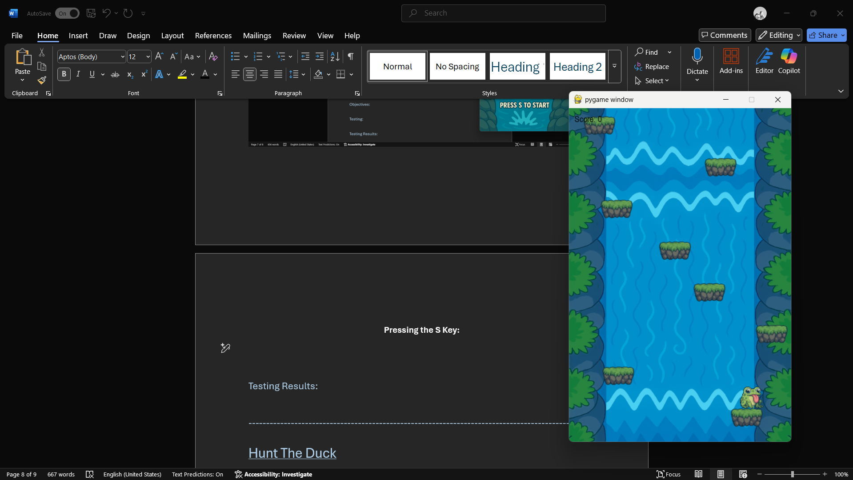

# Testing Game Loop:

**Animation & Physics**

* **Player animations** respond fluidly to gravity-based physics, transitioning seamlessly between idle, jump, and fall states.
* **Jump mechanics** are tightly synced with sound effects, ensuring audio feedback is clean and responsive.
* **Player physics** are precisely tuned: each jump propels the player upward while the platform they launched from scrolls below the screen edge.
  + This intentional design prevents repeated jumps on the same platform, encouraging upward momentum and strategic scaling.
  + It’s a subtle but powerful mechanic that enhances challenge and replayability—brilliantly executed.

**Platform & Enemy Generation**

* **Platforms** spawn randomly and consistently, with no overlap, clipping, or spawn bugs observed during extended playtesting.
* **Spider enemies** generate exclusively on platforms, as designed, with flawless collision behavior and sprite switching every 2–5 seconds for added realism.
* No spawn glitches, stacking errors, or collision misfires were detected—enemy logic is stable and engaging.

**Scoring System**

* Score tracking is fully operational, incrementing accurately based on player progress.
* No desync or reset issues observed during multiple test runs.

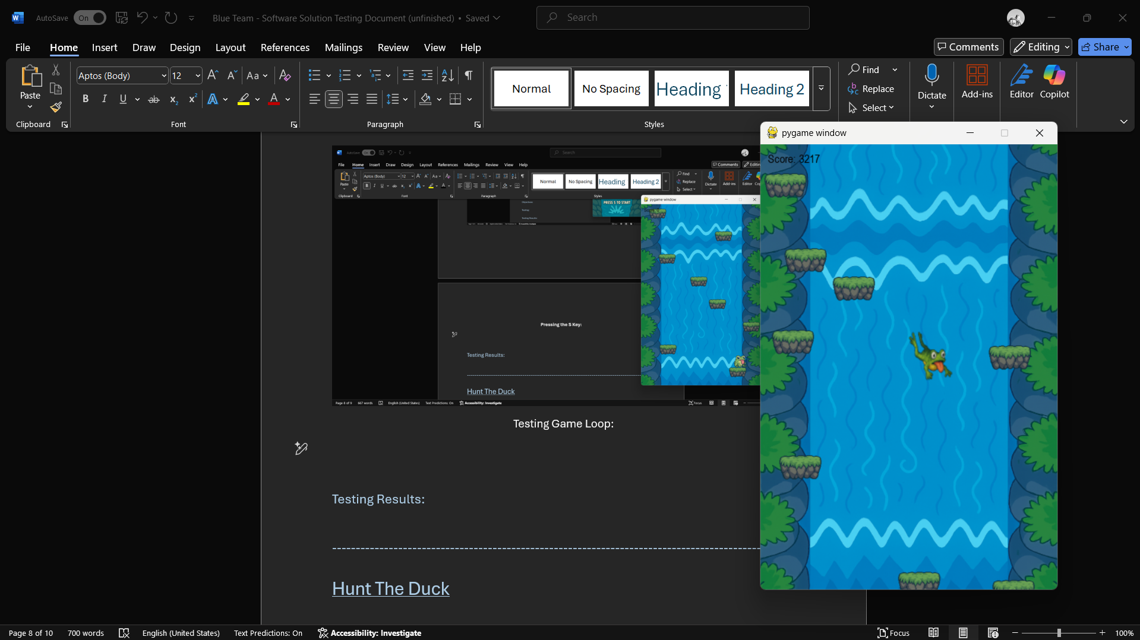

# Testing Collision with Enemy Sprite:

**Froggy Jump – Collision Behavior & Audio Overlap Issue**

**Observation:** During testing, an audio overlap was detected when the player collided with a spider from below while ascending. The collision triggered multiple sound instances in rapid succession, resulting in a distorted or “wonky” effect.

**Cause:** This behavior appears to stem from multiple collision detections occurring within a short timeframe, likely due to the player’s upward momentum intersecting the spider’s hitbox across several frames.

**Resolution Plan:** To ensure clean collision handling and prevent repeated sound triggers:

* Implement a **single-collision flag** for the player upon contact with a spider.
* Once collision is registered:
  + Trigger the appropriate sound effect.
  + Set the player to a “dead” state.
  + Disable further collision checks with enemy sprites.
  + Allow the player to fall through enemies without additional interactions.

**Outcome Goal:** After the initial impact, the player should enter a death sequence with no further collision responses—ensuring clean audio playback and preserving the intended visual flow.

### Overall Test Results:

**Status:** All enemy sprites are successfully generated at random intervals and positions, with spiders spawning exclusively on platforms as intended.

**Collision Logic:** Upon contact with a spider, the collision system correctly registers the hit and transitions the player into a death state. This triggers a natural fall toward the bottom of the screen, seamlessly initiating the death sequence.

**Result:** Collision detection and death flow are functioning as designed, with smooth transitions and consistent behavior across test runs.

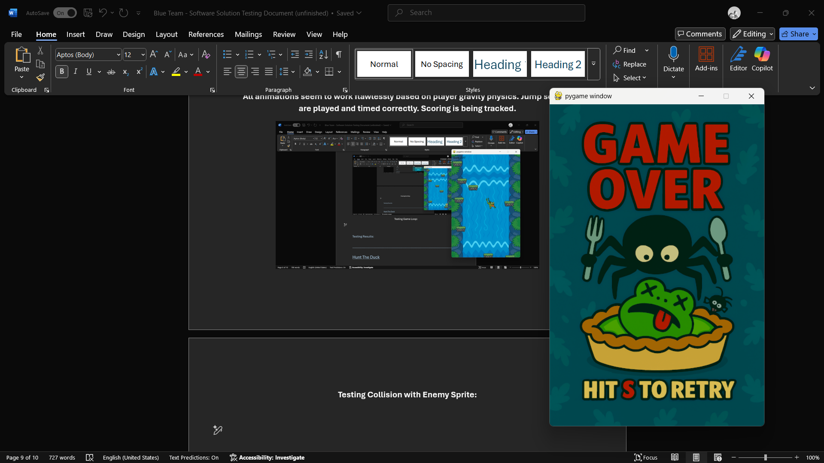

# Testing Death Scenes and Restart Functionality:

The test: I am going to play the game 10 times, taking a screenshot of the death scene displayed, and I will post them here in the order that I get them from left to right. This will showcase the restarting of the game loop with the S button as well as the random intention of the death scenes.

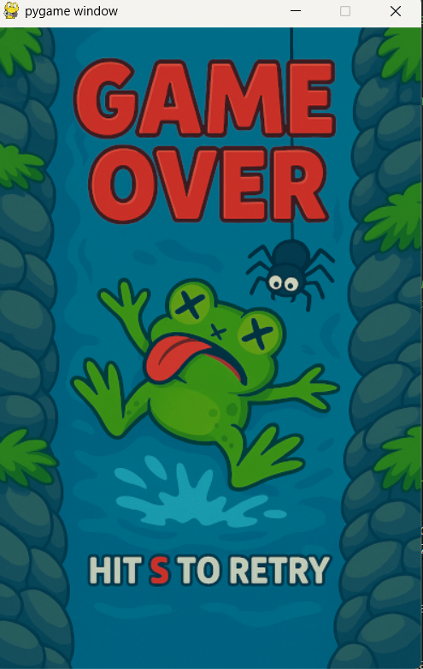 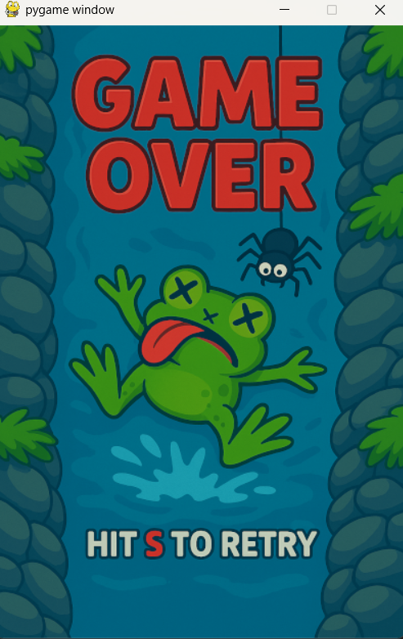 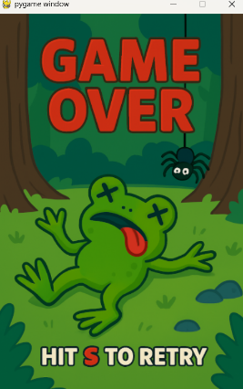 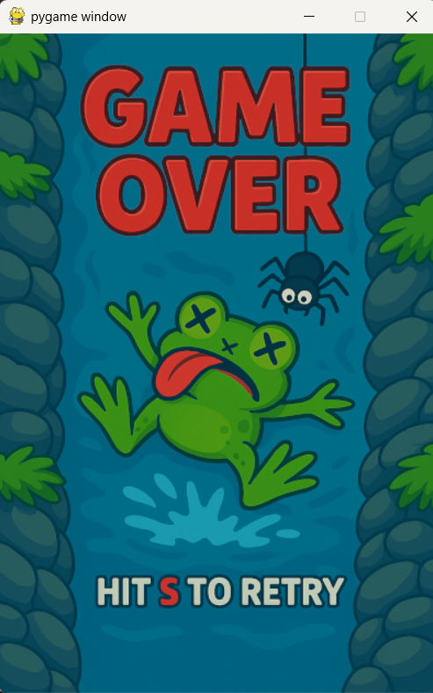 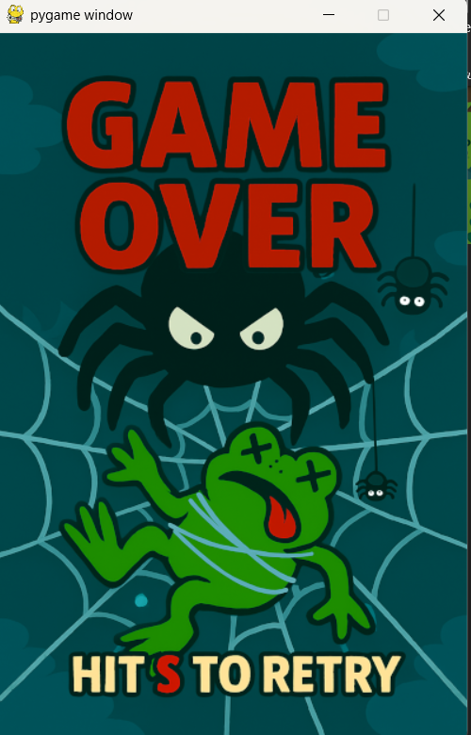

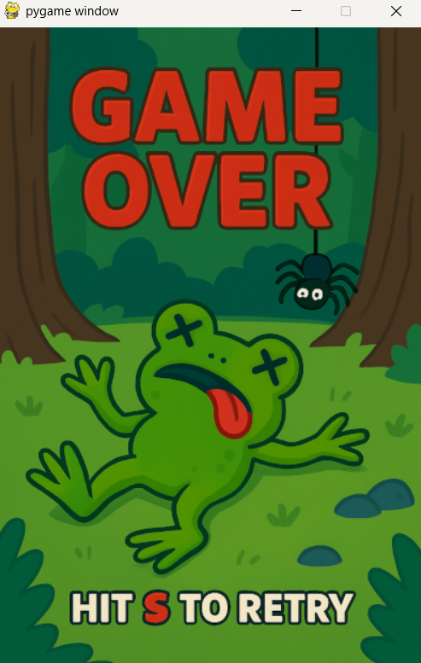 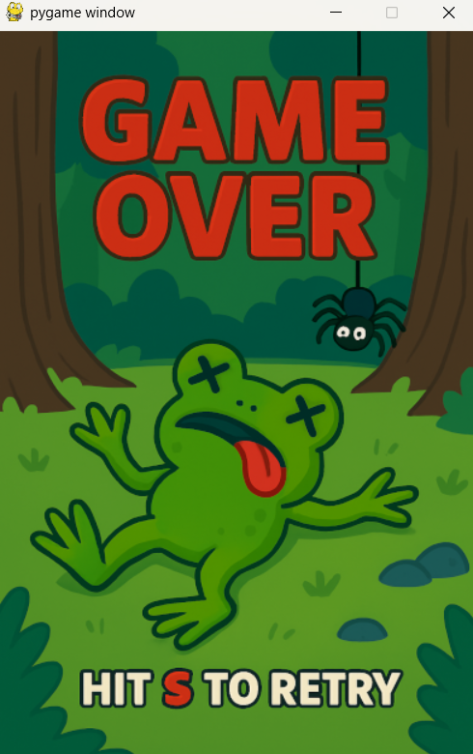 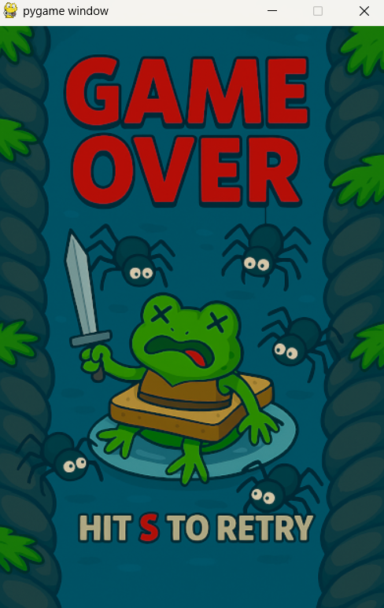 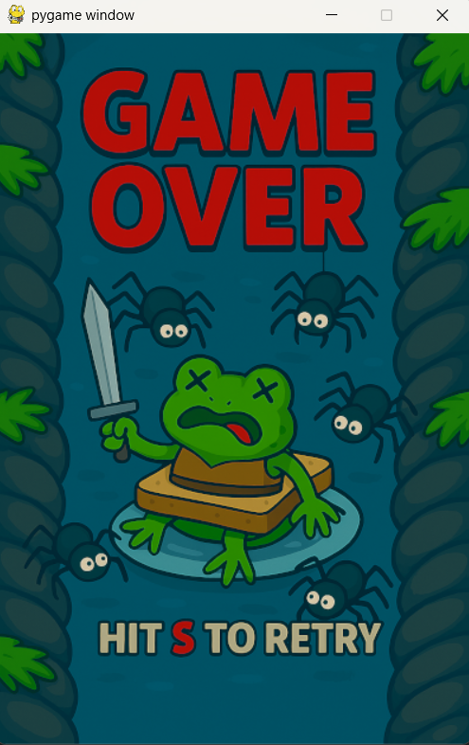 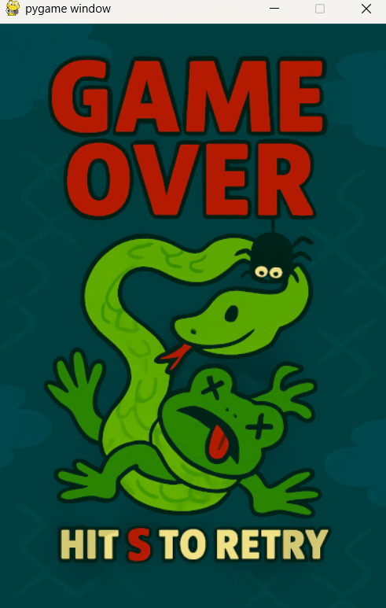

**Death Sequence and Restart Results:**

**Observation:** Death scenes are randomly selected from a pool of 13 images. While the system is functioning, certain images appear more frequently than others, suggesting a bias in the randomization or a lack of cooldown between repeats.

**Proposed Solution:** To preserve the randomness while avoiding repetition fatigue, implement a **death cooldown system**:

* Introduce a **death count variable** that tracks how many death iterations have occurred since each image was last used.
* When a death scene is selected, mark it as “cooling down” and temporarily remove it from the eligible pool.
* Unlock the image for reuse only after a defined number of deaths (e.g., 5 iterations).
* This prevents the same image from appearing twice in a row or too frequently, while still maintaining a sense of randomness and surprise.

**Why It Works:** This approach balances unpredictability with variety. It avoids the rigidity of full-cycle enforcement (which can feel too structured), while still ensuring that no single image dominates the experience.

# **Game Test Summary**

**Launch & Runtime Behavior**

* Pressing **S** from the start menu instantly launches gameplay with background music already active.
* No loading or control screen is shown, which may confuse first-time players. A brief pre-launch overlay with key bindings would improve onboarding.
* When minimized, the game enters a passive state: music continues, but logic and rendering freeze. This allows full PC use without interference—a subtle but impressive technical win.

**Game Loop & Core Mechanics**

* **Animations** respond fluidly to gravity-based physics, with seamless transitions between idle, jump, and fall.
* **Jump physics** are precisely tuned: platforms scroll below the screen after launch, preventing repeated jumps and encouraging upward scaling. This intentional design adds challenge and replayability.
* **Platforms and spiders** generate randomly and bug-free. Spiders spawn only on platforms and switch sprites every 2–5 seconds for added realism.
* **Scoring system** tracks progress accurately with no desync or reset issues.

**Collision Logic & Audio**

* Collision with spiders works as intended, triggering death and a natural fall to the bottom of the screen.
* An audio overlap bug was observed when colliding from below while ascending—likely due to multiple collision detections across frames.
* **Fix proposed:** Add a single-collision flag to prevent repeated triggers, disable further enemy collisions post-impact, and allow clean fall-through.

**Death Sequences & Replayability**

* Death scenes randomly select from 13 images, but some appear more frequently than others.
* **Fix proposed:** Introduce a cooldown system using a death count variable. Once an image is used, it’s locked out for a few iterations (e.g., 5 deaths) before re-entering the pool.
* This preserves randomness while avoiding repetition fatigue and enhances replayability.

**Overall Assessment**

Froggy Jump is stable, engaging, and technically sound. Key mechanics like platform scroll logic and minimized-state behavior show thoughtful design. With minor refinements—like control overlays, collision flagging, and death scene cooldowns—the game is well-positioned for a polished, replayable experience.

### --------------------------------------------------------------------------------------------------

Hunt The Duck

### Objectives:

* Create/implement background image
* Create/implement duck sprites
* Create/implement duck movement logic
* Create/implement duck death state
* Create/implement mouse-based shooting mechanic
* Create/implement sight reticle
* Create/implement scoring system
* Create/implement game over logic
* Create/implement win condition
* Create/implement start screen
* Create/implement restart functionality
* Create/implement duck2 activation logic

Testing Hunt the Duck

# Initial Launch:

Upon launching the game, the player is immediately greeted with a vibrant, visually engaging **green title screen**. The bold “**Hunt The Duck**” header is prominently displayed, establishing the game’s identity with clarity and charm.

A custom **scope-style mouse pointer** replaces the default cursor, instantly reinforcing the shooting theme and immersing the player in the gameplay context. Below the title, a clear instruction—**“Press SPACE to Start”**—provides intuitive guidance without clutter.

While minimal in complexity, this launch sequence succeeds in setting the tone, delivering a clean and focused entry point that feels both playful and purposeful.

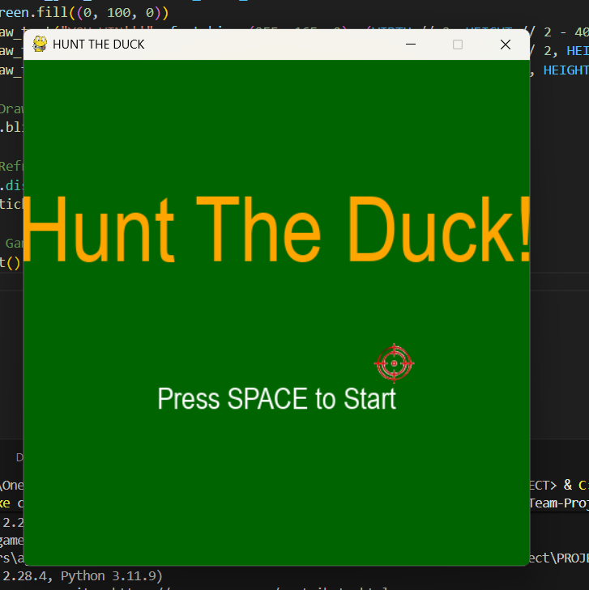

# Start Screen Transition – *Pressing SPACE to Start*

Upon pressing the **SPACE key**, the game transitions instantly from the title screen into the main gameplay loop. The shift is seamless, with no delay or loading artifacts—delivering a snappy and responsive start.

The player is greeted by a charming **farm-style background**, complete with a visible farmhouse. And yes, **in this game, it’s perfectly acceptable to aim toward the house… as long as it’s to bag a duck**! The setting reinforces the playful tone while keeping the action grounded in a lighthearted rural theme.

A duck immediately begins flying across the screen with **smooth motion and zero lag**, showcasing stable frame handling and clean sprite updates. If the player chooses not to shoot, there’s no penalty—another duck quickly spawns in a slightly different location, maintaining game flow and pacing.

The **scoring system** is cleverly tucked into the cloud layer at the top of the screen. It’s unobtrusive yet always visible, blending naturally with the background while keeping the player informed.

**Result:** The transition from title to gameplay is fast, stable, and visually engaging. The background, duck behavior, and scoring placement all contribute to a polished first impression.

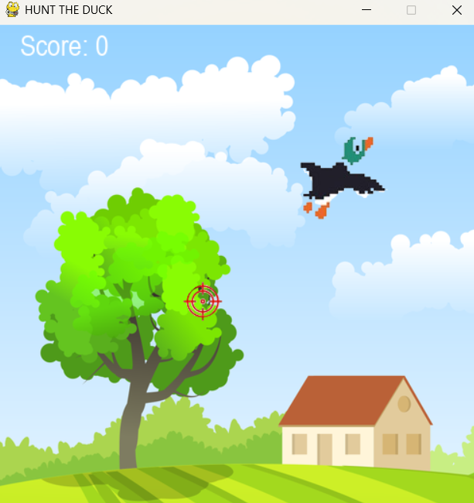

# Testing Game Loop & Physics:

The gameplay loop delivers a smooth and engaging experience. As ducks are successfully shot, their **movement speed increases**, introducing a natural difficulty curve that keeps the player on their toes.

At **10 points**, a second duck begins to **emerge from the edge of the screen**, prepping for takeoff. By **11 points**, it joins the flight path, adding complexity and visual variety. Both ducks continue to accelerate as the score climbs, maintaining momentum and challenge.

When a duck is hit, its sprite **flashes red and falls to the bottom of the screen**, clearly signaling a successful shot. The animation is clean and satisfying, reinforcing the “bagged that ducky” moment with flair.

If the player **misses a duck**, the game instantly transitions to a **Game Over screen**, which prompts the user to press **R to restart**. This reset works flawlessly, refreshing the game loop and restoring all elements to their original state without delay or glitch.

**Result:** The game loop is responsive, fun, and stable. Duck behavior scales with player performance, animations are clean, and restart logic is seamless. Delivering a tight, replayable experience with just the right dose of challenge.

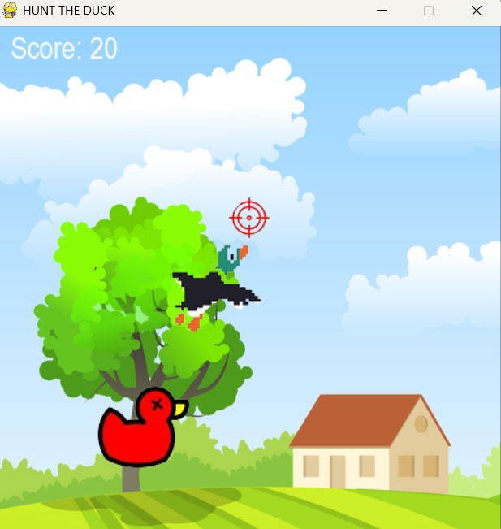 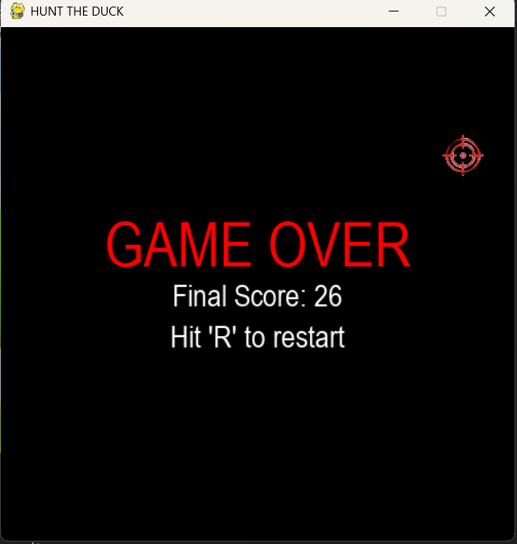

**Hunt the Duck – Final Testing Summary**

**Overall Performance**

*Hunt the Duck* has been thoroughly tested across all core systems and user experience flows. The game demonstrates exceptional stability, responsiveness, and charm, with **zero functional flaws** observed during testing.

**Launch & Transition**

* The game opens with a vibrant green title screen featuring bold branding and a custom scope-style cursor.
* Pressing **SPACE** transitions instantly into gameplay with no lag or delay.
* The farm-style background sets a playful tone—yes, even shooting toward the house is fair game, as long as it bags a duck.

**Gameplay Loop**

* Ducks fly smoothly across the screen with no stutter or frame drops.
* Shooting ducks increases their speed, introducing a natural difficulty curve.
* At **10 points**, a second duck emerges and joins the flight path at **11 points**, adding variety and challenge.
* Hit detection is precise: ducks flash red and fall with gravity, clearly signaling success.
* Missed shots trigger a flawless **Game Over screen**, with **R to restart** working instantly and reliably.

**Scoring & UI**

* The scoring system is cleanly integrated into the cloud layer—visible, unobtrusive, and thematically consistent.
* Score updates are accurate and real-time, with no desync or display issues.

**Runtime Stability**

* When minimized, the game enters a passive state:
  + Background music continues uninterrupted.
  + Game logic freezes, preventing unintended behavior.
  + The game remains non-intrusive, allowing full PC use without interference.

**Final Assessment**

*Hunt the Duck* delivers a polished, bug-free experience with responsive controls, smooth transitions, and charming visuals. Its simplicity is its strength—every mechanic works as intended, and the game loop is tight, replayable, and fun. With zero flaws detected, this build stands as a successful and complete implementation

### --------------------------------------------------------------------------------------------------

# Tower Defense:

### Objectives:

### Testing:

### Testing Results:

### --------------------------------------------------------------------------------------------------

# David Vs Goliath

### Objectives:

### Testing:

### Testing Results:

### --------------------------------------------------------------------------------------------------